

WEB ENGINEERING

SE-206

PROJECT TITLE:

StayFit Website





SUBMITTED BY:

Munnazzah Aslam (SE-007)

SUBMITTED TO:

Miss Uzma Zehra

Abstract:

As we all know that the greatest wealth is health and in recent times when technology is advancing day by day people are now becoming self-aware and always seeking to have a healthy body fitness but they need something to motivate them in continuing their fitness journeys and not give up. Therefore, I decided to make a web-based solution for this problem. StayFit help users to manage the health life system in health fitness and nutrition. The project displays videos for exercise, and the preparation of healthy eating, determine BMI and your current health situation and calculates calories either acquired or burned also gives customized diet plans according to the user needs. This website is developed using two methodologies they are Prototyping model and Spiral prototype in order to reach a high-quality product and serves the user's requirements. Moreover, the front-end is implemented using HTML, CSS, JS while the backend is made in MySql using XAMPP Server.

Problem Statement:

It is with no doubt that regular exercise and physical activity contribute to body fitness and psychological health. Some of the well-known benefits of exercise are controls weight, combats health diseases, improves emotional stability, promotes better sleep. However, the World Health Organization (WHO) data reveals that more than 60% percent of the world’s population is not physically active enough to induce health benefits. The reason behind it seems to be the lifestyle choice. Thanks to modern gadgets and tools, domestic activities and occupational activities do not require much of physical activity. Massive mode of transport is also to blame for the declining physical activity levels. The fault is not always ours. Urbanization has resulted in environmental factors which may discourage physical activity. Population explosion, increased levels of crime, high density traffic in cities, air pollution, and lack of parks or greeneries, all contribute directly or indirectly toward physical inactivity. The consequence of rising physical inactivity is, as reported by WHO, it has been identified as the fourth leading risk factor for global mortality and contributes to six percent of deaths globally. I, therefore decided to make a website keeping in mind the people’s addiction to the internet and their mobile phone that can help and motivate them to stay fit and active by allowing them to track their calorie intake and my getting their BMI checked to know whether they are healthy or not. The members can also watch healthy recipes, read blogs on health by fitness trainers and can also find exercises according to their body type and needs, their burned calories by doing the exercise can also be calculated from this website. In this way, **StayFit** will help people to do regular exercises so that they stay healthy and not indulge in any disease.

Purpose:

**StayFit** is a website that tracks diet and exercise to determine optimal caloric intake and nutrients for the users' goals and uses gamification elements to motivate users.

How does StayFit work?

Using StayFit is very simple. Here's how our basic process works:   
  
1. Based on your fitness profile, we'll recommend a daily Net Calorie target for you to achieve your weight loss (or gain) goals.   
  
2. As you eat throughout the day and perform different exercises, you need to log your meals and exercise in StayFit food and exercise options. StayFit will calculate the number of calories you've consumed from food and burned from exercise and let you know how many calories you have left to eat for the day. If you stick within your calorie limits, you should achieve the weight loss (or gain) you're looking for.   
  
3. The best part of our system is the ease of use for our users. StayFit remembers the foods and exercises you like most and makes it easy for you to add those items to your diary.   
  
4. Periodically (we recommend once a week), you should weigh yourself and check-in your new weight with the site or the app using our Check-In feature (or "Progress" page in the app). Checking in your weight allows us to track your progress over time and also adjust your calorie goals to reflect your new weight. You can also check your BMI to know if you are underweight, overweight or fine.  
  
That's it! Just a few minutes a day can show you so much about what you're eating and how that impacts your health.

Software Qualities:

1. **Security:**

Since it will be dealing with personal health data, requires that the information be secure. The login/logout features are therefore intended to address this concern.

1. **Availability**

StayFit needs to be available to users at all times when they have an internet connection.

1. **Usability**

StayFit needs to be simple-to-use and efficient. These concerns will be addressed by making beautifully designed and easy to understand website so that every type of user can use it to achieve their goals.

1. **Scalability**

StayFit is intended to scale into a website that can track all health data in one place (standardized and centralized). The app should be extremely scalable for this purpose.

1. **Reliability**

StayFit should be extremely reliable.

1. **Efficiency**

StayFit should be extremely efficient.

1. **Portability**

StayFit should be portable. This concern is addressed by having a website that is compatible on iOS, Android, Windows.

Non-functional Requirements:

1. The software will only use the English language.

2. In general, it is required that a user be always connected to the internet to use the application.

3. Limits to calories consumed / burned and hours slept must be daily inserted.

4. No other database can be used aside from StayFit Server.

5. Units cannot be selected for calories.

6. The mobile apps will not have a landscape orientation.

7. The only emails sent from the server are account creation confirmation and password reset.

Functional Requirements:

1. **Create Account**

Goal: Allows users to sign up for an account with StayFit. This registers users in StayFit server.

1. **Login**

Goal: If the user has logged out and needs to log back in or needs to log in from a different device, this functionality allows him/her to do so.

**c. Input Calorie Intake**

Goal: To allow users to enter meals, recipes, or ingredients to provide an estimate of total calories consumed in meal.

1. **Watch Recipes**

Goal: To help users learn new recipes that can help them achieve their goals faster.

1. **Input Calories Burned**

Goal: To allow users to enter information about the exercises they have done throughout the day in order to know the number of calories burned.

1. **Search Exercises**

Goal: To allow users to get information about different exercises that they can do on a daily basis in order to achieve their goals.

1. **View Graphs**

Goal: To allow the user to view their progress.

1. **Logout**

Goal: To allow users to logout (in the event of getting a new device, or allowing someone else to log in).

1. **Delete Account**

Goal: To allow users to delete their account.

1. **BMI Calculator**

Goal: Users can calculate their BMI by the weight and height information that they have provided in order to know whether they are underweight, overweight or normal.

Planning:

Project Charter:

Objective

The main objective of this project is to achieve physical fitness and improve the level of health of the users by helping and motivate them to doing sports exercise and eating healthy food.

Scope:

**StayFit** mainly includes the following areas: [Active life style](https://www.omicsonline.org/aerobics-and-fitness.php), [Health fitness, Body Mass Index](https://www.omicsonline.org/aerobics-and-fitness.php), and also relates to lifestyle habits like [Physical training](https://www.omicsonline.org/aerobics-and-fitness.php) ,[Diet and fitness](https://www.omicsonline.org/aerobics-and-fitness.php), [Cardio exercise](https://www.omicsonline.org/aerobics-and-fitness.php).

Assumption:

StayFit is based on the assumption that the current system on which the website is running have accurate time and the details entered by the users are also correct.

Constraints:

StayFit is designed to serve only Asian Countries for now but in future it will be serving others as well.

Time:

StayFit took four months from starting point of requirement gathering and analysis to the implementation and delivery.

Quality Criteria:

StayFit is designed to provide all the features mentioned with the assurance of security, availability, usability and reliability of users.

Major Risks:

Privacy:

Personal information entered by the user should not be exploited.

Results:

The likeliness of results and achievement of the goals of a particular client and the guarantee of completion of goals in a small period of time is a risk.

Cyber risks:

Websites are often easier to hack, which means that users’ data—their names, addresses and credit card information—could be a target for cyber criminals. As more and more people move to online solutions for fitness facilities, proper cyber-security measures are becoming vital.

Project Methodologies:

The project is implemented by two methodologies; each methodology contains set of phases. The first methodology is prototype model includes requirements gathering phase, quick design phase, build prototype phase, user evaluation phase and prototype refinement phase. The second methodology is spiral model include iterative phases of design, implementation, testing and maintenance.

We use prototype model because the requirement of the project is not exhaustive and we need to suggestions and contribution into the project in detail to complete all possible functionality of StayFit Website. In addition, prototyping model should be used to desire system needs to have a lot of interaction with the end-users to reduce risk of failure and better fit into customer requirements.

We use spiral model to complete the development phases on the system after reaching the final prototype in order to reach a high-quality product and serves the user's requirements. 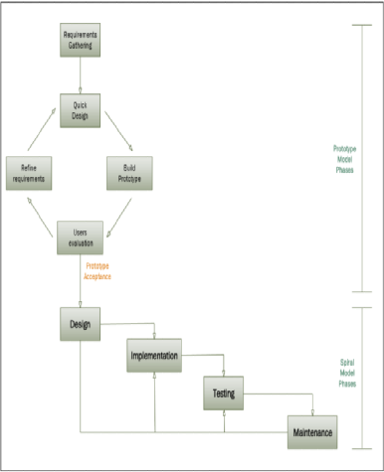

Sitemap:

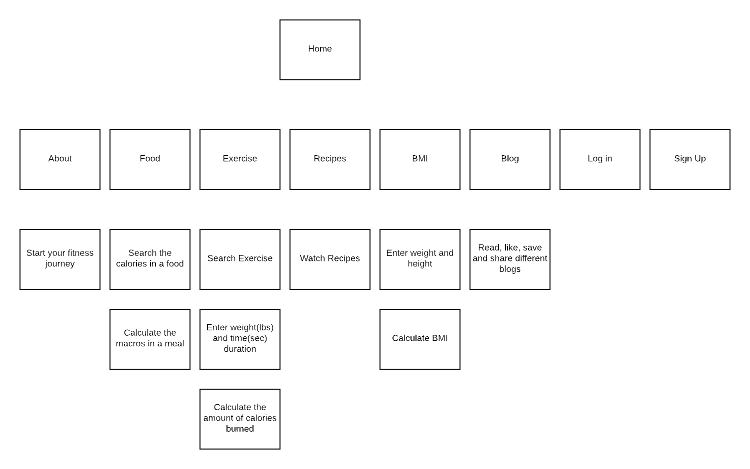

Designing:

Wireframe: 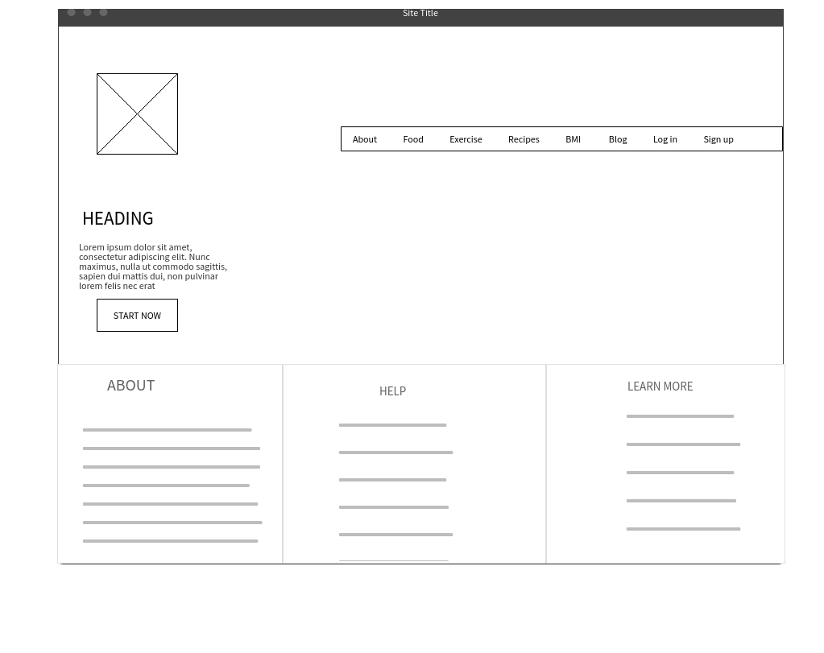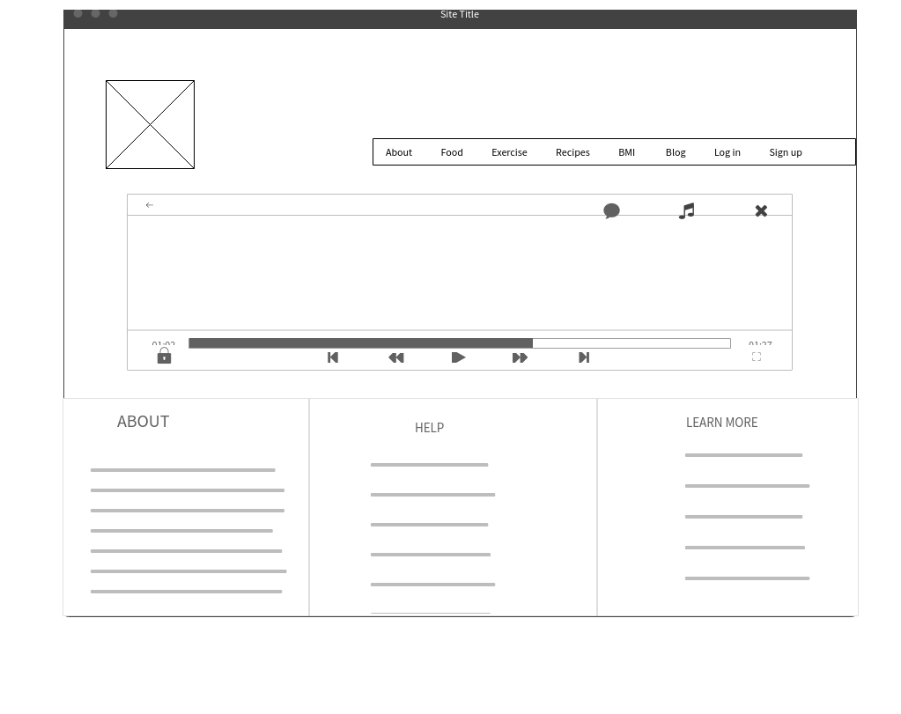

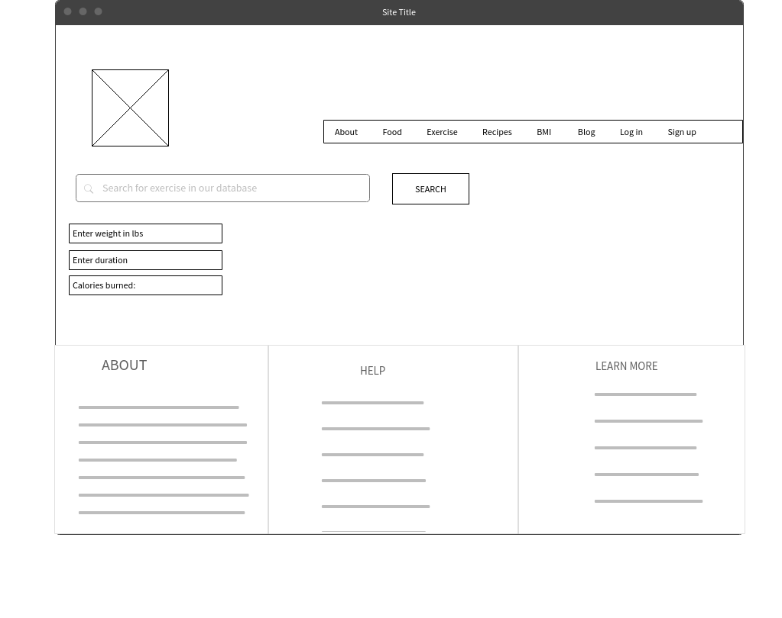 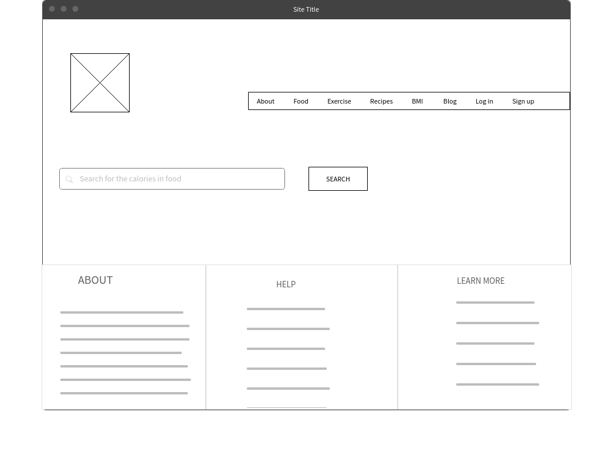 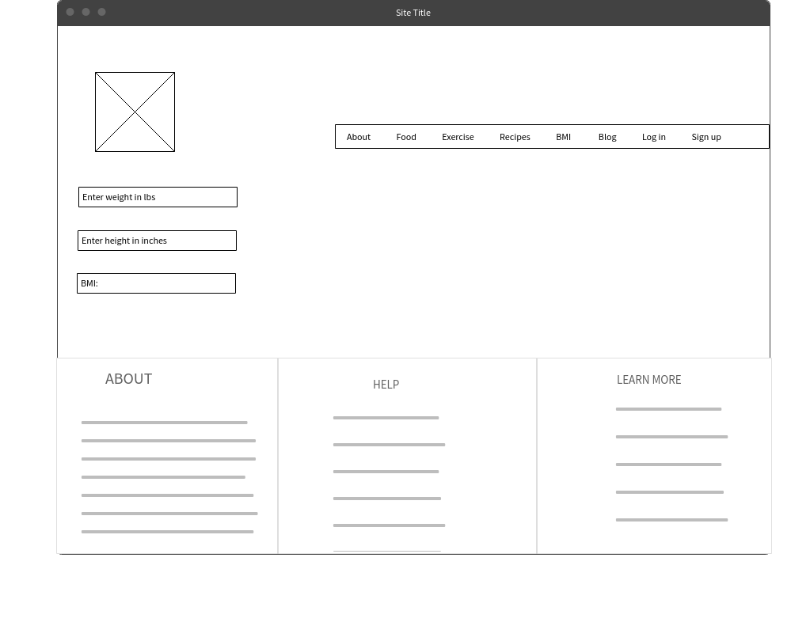 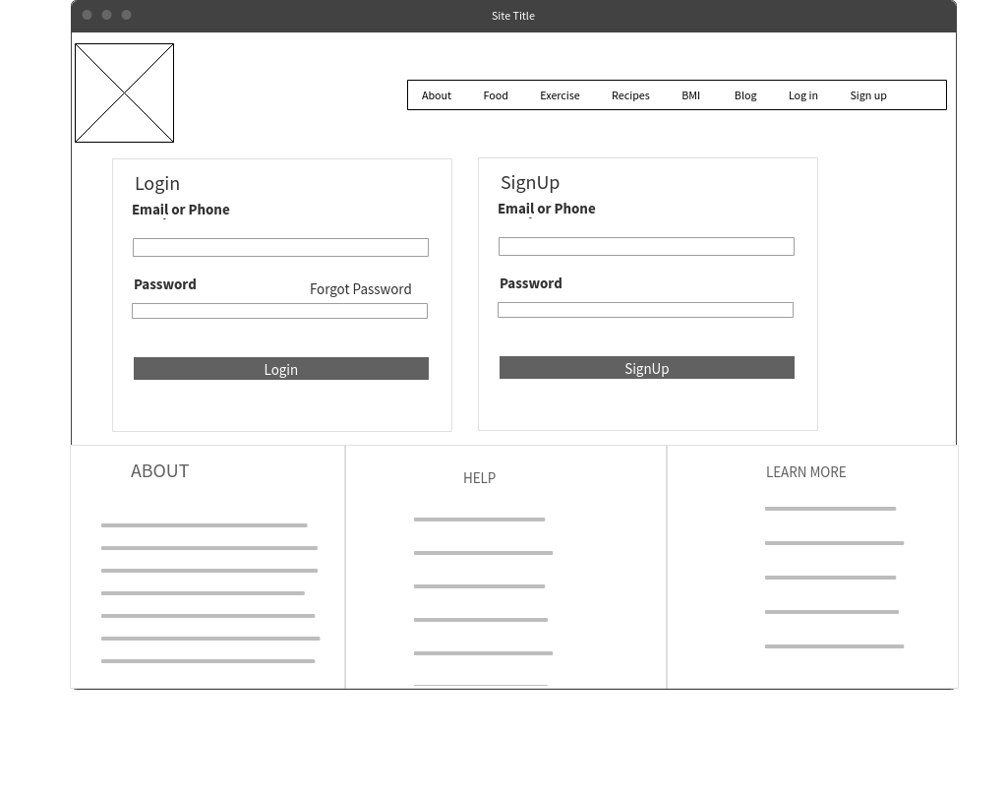

GANTT Chart:

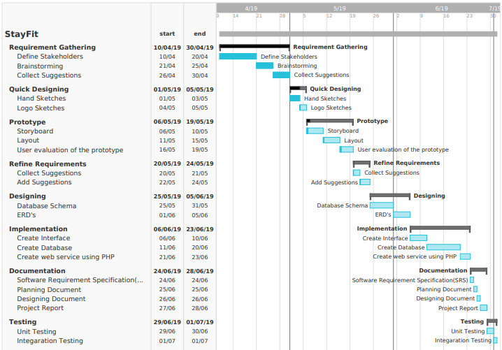

Use-case Diagram:

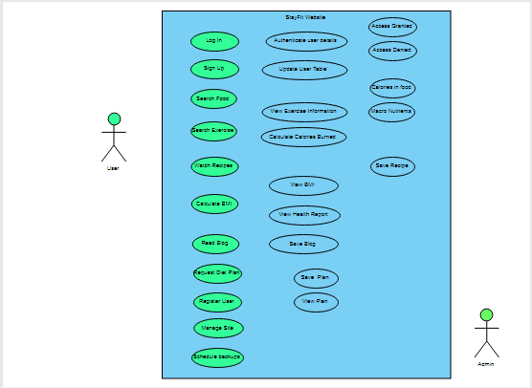

Website Interface:

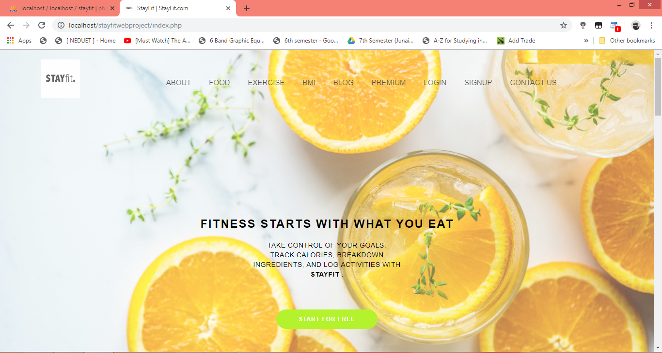  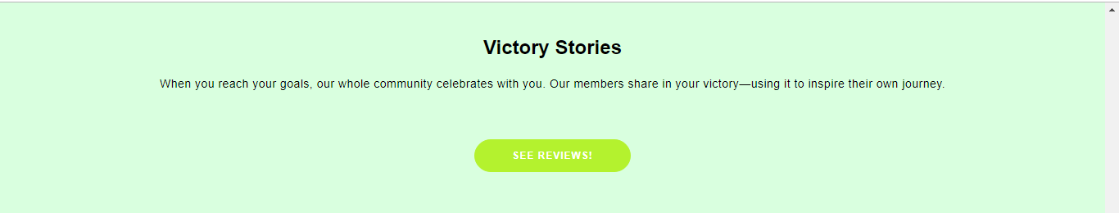

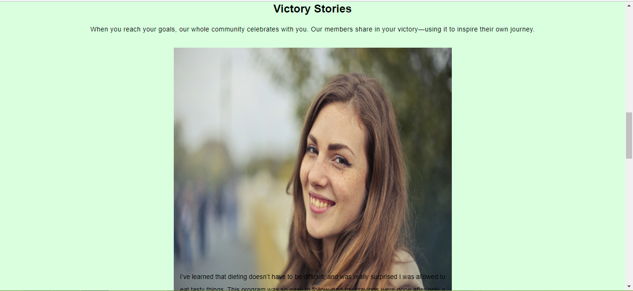  

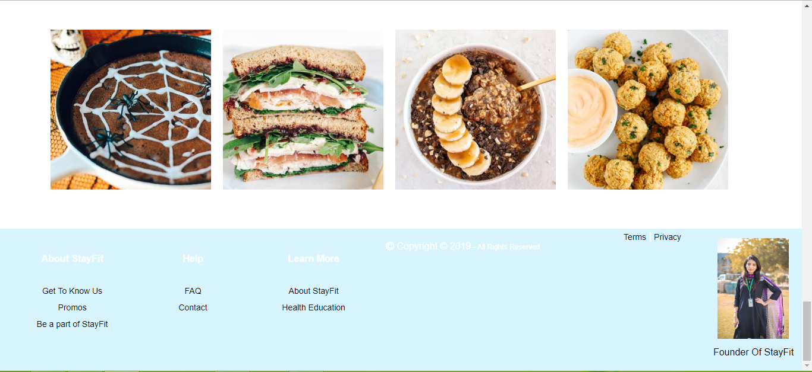

Sign In:

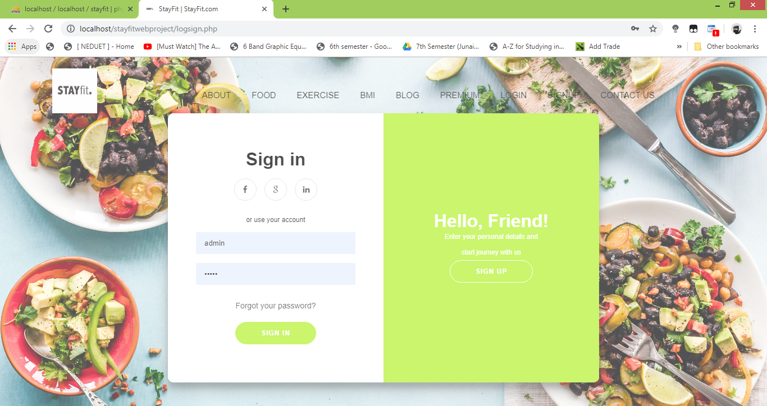

Sign Up:

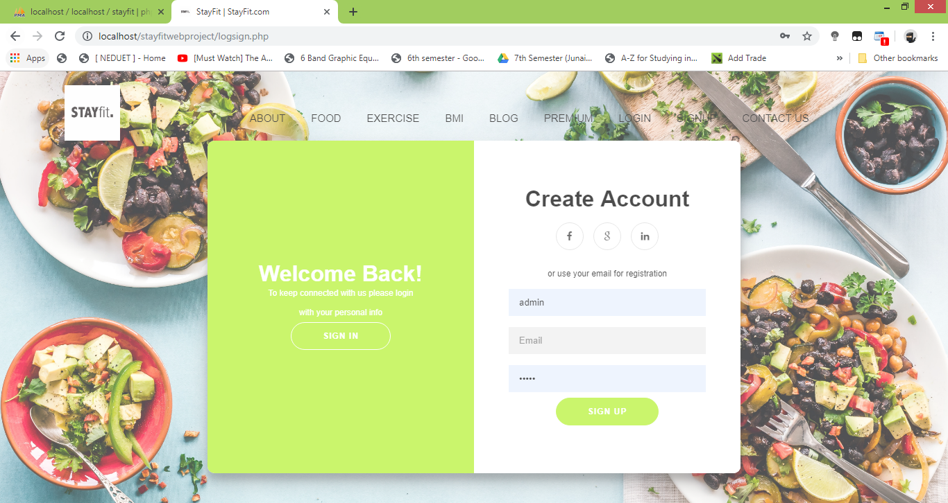

Blog:

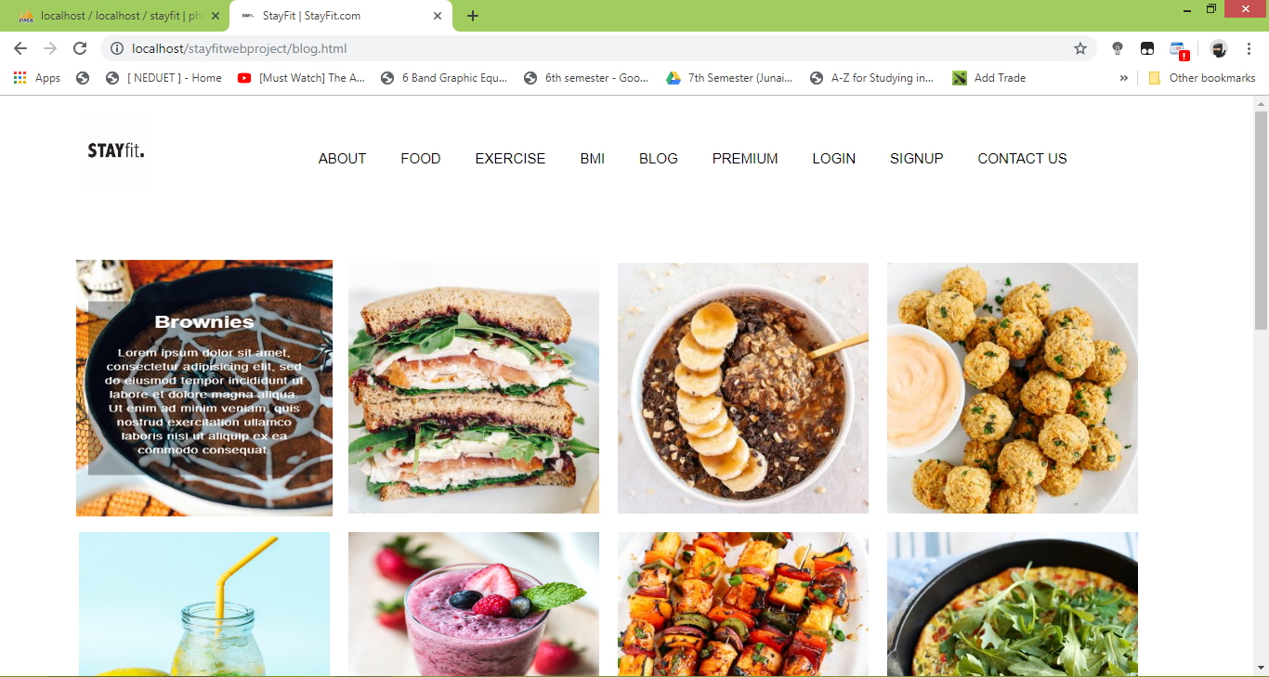 

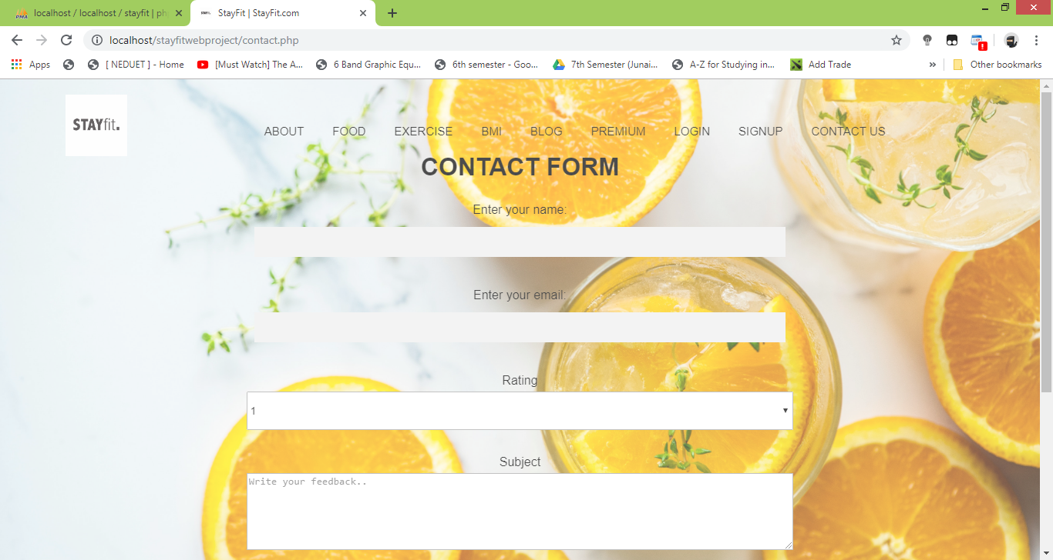

Packages:

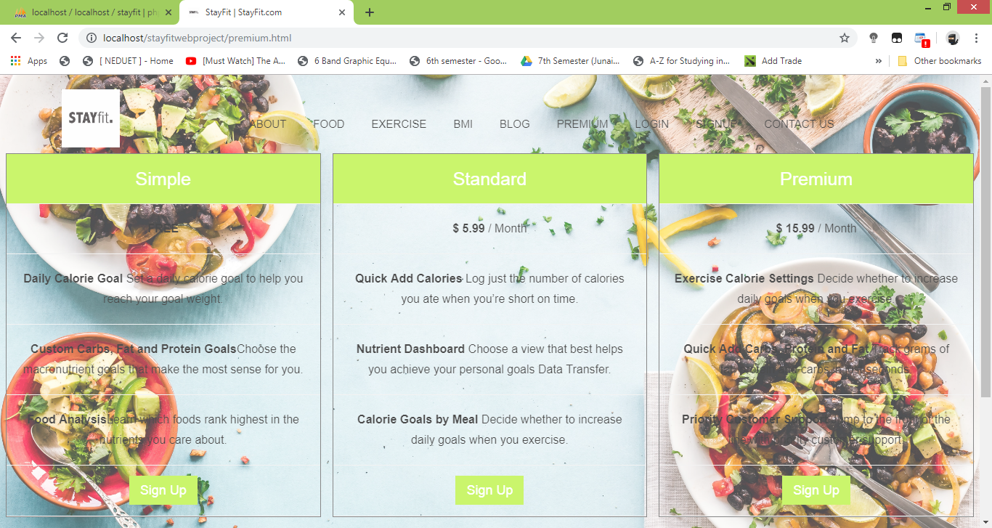

BMI Calculator:

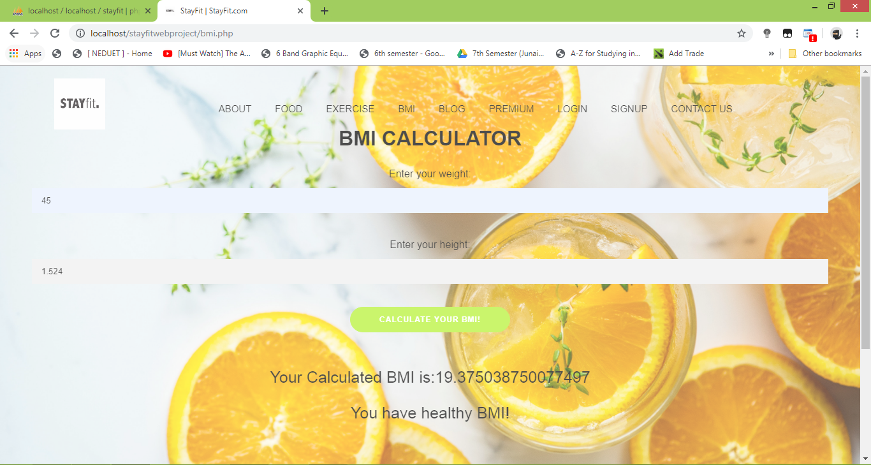

Food Search:

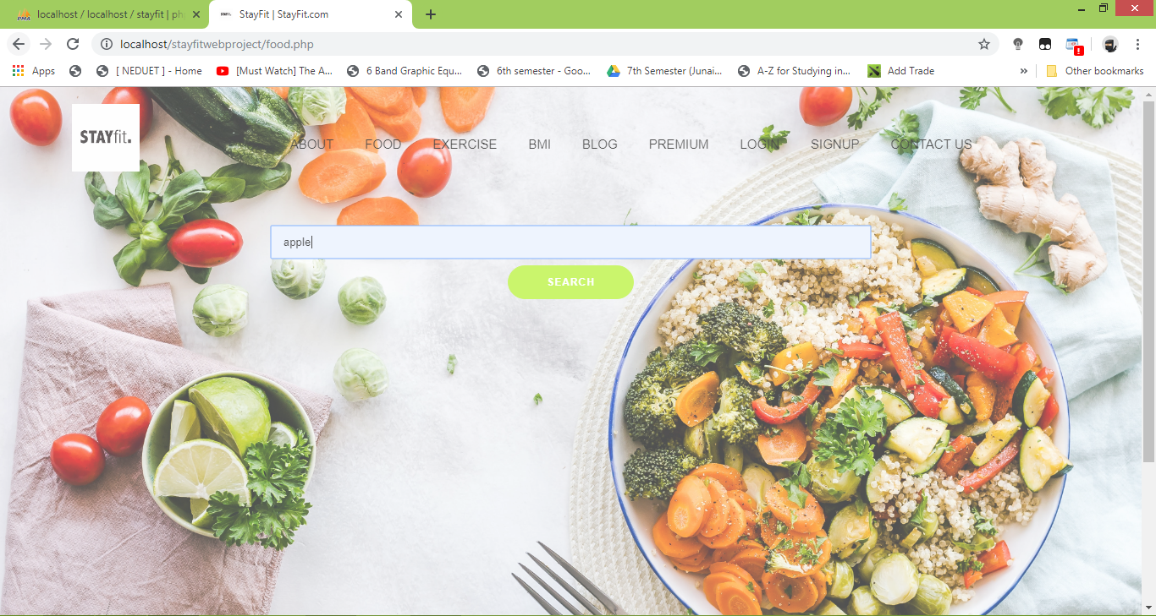

Exercise Search:

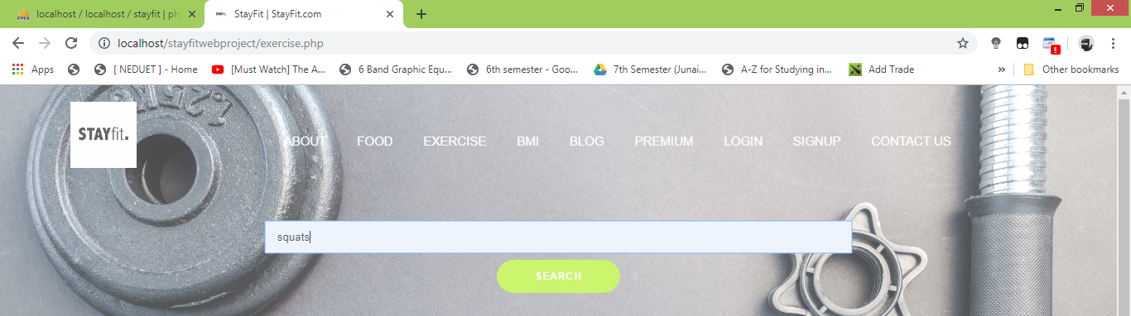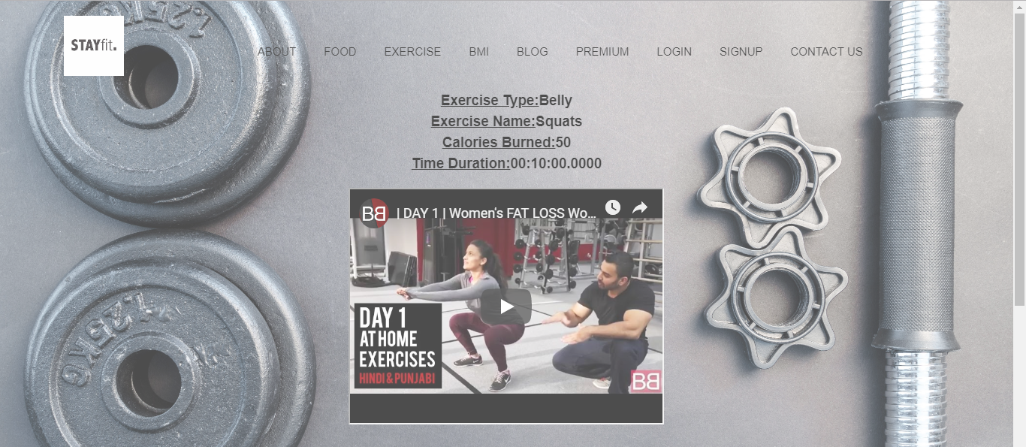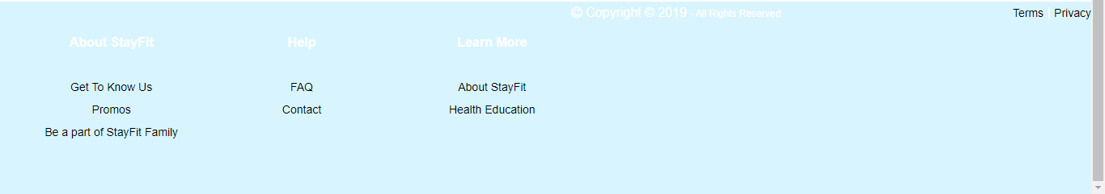

Enhanced Entity-Relationship Diagram (EERD):

